Coin Based Cola & Soda Vending Machine

Cola vending machines have long been used for electronically powered vending purposes in malls, theatres. These machines make use of electronic circuitry to deliver products on accepting payments from the consumer. For this purpose they have inbuilt circuitry with motors and a sensor based circuitry. Lets us study the working and fabrication of a cola vending machine using this demonstration system of a small vending machine. The project makes use of a custom fabricated frame using a vending setup fitted with motors and authentication system. The authentication system consists of a coin based authenticator. It detects the coin inserted by user and verifies if it is a valid coin. In case of valid coin detection a signal is sent to the internal circuitry which also consists of a microcontroller. The microcontroller now operates the motors to dispense a cola bottle in case of a valid coin else reject the coin if found invalid. The motors are fixed in a cabin and are fixed with a outlet shaft which releases a cola can in case the motor is operated. Thus we study the working and fabrication of a cola &soda vending machine using this mechanism.

Block Diagram:

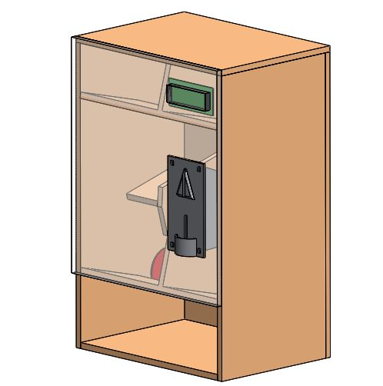

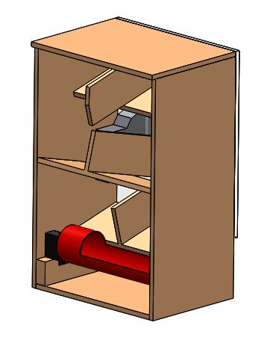

Components
- Microcontroller
- Coin Module
- Servo Motors
- Outer Frame
- Shaft
- Hinges
- Supporting Frame
- Mounts & Joints
- Resistors
- Capacitors
- Diodes
- Screws & Bolts

Advantages
- Easy To Use
- Automatic Operation

